# 1. PURPOSE OF THE UNIT (SECTION / INSTALLATION)

1.1. Brief description of the unit purpose

The activator of chromium catalyst used in the package unit 40-PK-2002 is designed to convert the original chromium catalyst Cr(III) into its active form Cr(VI). The activation unit operates in the intermittent mode based on the algorithms developed for different process conditions (cases) to produce various grades of HDPE. The chromium catalyst activation unit is used for production of HDPE and LLDPE/HDPE.

The main immediate advantages of the catalyst activation at the site are given below:

- chromium catalyst supplied by an independent party in the non-activated form in order to reduce costs and provide for a higher quality of the activated product;

- the stages of thermal activation at the site in the catalyst activator make it possible to accurately adjust the properties of the catalyst in accordance with the production requirements;

- no HSE problems during transportation caused by the presence of carcinogenic substances (CrVI).

Non-activated chromium catalyst is supplied to the HDPE production facility in 200- liter drums. The operating quantity of the catalyst loaded into the activator is equal to the batch volume and makes up 3 m3 (12 drums). The following four brands of chromium catalyst are used:

- chromium catalyst ЕР30Х, batch (operating quantity) – 680 kg;

- chromium catalyst ВС963 (Magnapore 963), batch (operating quantity) – 440 kg;

- chromium catalyst PQС24340, batch (operating quantity) – 696 kg.

- chromium catalyst PD11074, batch (operating quantity) – 600 kg.

All these catalysts contain chromium in the trivalent state applied to the inert silicon carrier. Before use in the polymerization process, the catalyst shall be activated at a high temperature, which also serves to remove water and hydrocarbons from the catalyst in its initial condition.

The type of a catalyst and the activation profile are determined considering the target grade of the resulting polymer.

The activation profile determines the parameters of the process conditions: batch weight, activation temperature, intensity of temperature changing, temperature exposure time, consumption of a working medium (nitrogen, air) at various stages of the activation process.

The chromium catalyst activated in the fluidized bed by oxidation of the trivalent chromium with air oxygen under the pressure close to the atmospheric one, in the temperature range from the ambient temperature to 900 ° C. At that, the chemical equilibrium between the trivalent and hexavalent forms of chromium shifts towards the hexavalent form, and chromium binds to the carrier made of silicon dioxide.

The chromium catalyst activation unit is a part of the of high-density polyethylene (HDPE) production facility; it is common for the production lines HDPE-1 (Line 41) and HDPE-2 (Line 42). The unit is serviced by polymerization operators of 5 and 6 grades.

**2. SPECIFICATIONS OF FEEDSTOCK, MATERIALS, REAGENTS, CATALYSTS,**

**INTERMEDIATES, FINAL PRODUCTS**

**2.1. Quality parameters of feedstock, materials, reagents, catalysts, intermediates and final products**

Quality parameters of feedstock, materials, reagents, catalysts, intermediates and final products are given in Table 2.1.

Table 2.1

| №  п/п | Name of feedstock, materials, intermediates and utilities | National standard, technical specifications, regulations or method for feedstock preparation, company standard | Rates to be checked up on a mandatory basis | Standard value  (according to GOST, Technical Specifications, company standard) | The area of application of manufactured products |
| --- | --- | --- | --- | --- | --- |
| 1 | 2 | 3 | 4 | 5 | 6 |
| 1 | Chromium catalyst (chromium applied to silicon oxide carrier) C-24340 | Vendor’s standard | Mass fraction of Сr and chromium (III) compounds, % | 1 | Catalyst |
| Mass fraction of chromium compounds, % | 90 |
| 2 | Chromium catalyst EP30X | Vendor’s standard | Mass fraction of synthetic amorphous silicon, %, more than | 85 | Catalyst |
| Mass fraction of water, %, less than | 10 |
| Mass fraction of chromium (III) compounds, %, less than | 5 |
| pH value (5 % water solution of the substance) | 3 - 10 |
| 3 | Chromium catalyst Magnapore 963 | Vendor’s standard | Density (bulk), kg/m³ | 400 - 600 | Catalyst |
| Melting temperature, ᵒС, minimum | 999 |
| Water solubility, weight %. | Partially soluble |
| 4 | Chromium catalyst PD 11074 | Vendor’s standard | Mass fraction of synthetic amorphous silica, weight %., more than | 86 | Catalyst |
| Mass fraction of chromium (III) compounds, weight %, less than | 2.5 |
| Mass fraction of water, %, less than | 6 |
| pH value (5% water solution of the substance) | 3 - 10 |
| 5 | Electric energy |  | Voltage, kV | 10 |  |
| Frequency, Hz | 50 |
| 6 | Purified MP Nitrogen  (from LLDPE/ HDPE production process) | Provisional Process Regulations for LLDPE/ HDPE production process  ТР-ЗСНХ-10-18 | Nitrogen content, vol.%, more than | 99.9 | Used for pressure generation in vessels |
| Oxygen content, vol. ppm, less than | 0,1 |
| СО content, vol. ppm, less than | 0,1 |
| СО2 content, vol. ppm, less than | 0,1 |
| Water content, vol. ppm, less than | 0,1 |
| Hydrogen content, vol. ppm, less than | 5 |
| Inert gases’ content, vol. ppm, less than | 5 |
| N2O content, vol. ppm, less than | 0,5 |
| Sulfur content, vol. ppm, less than | 0,1 |
| 7 | Process air | GOST ISO 8573-1-2016 | Pollution class according to GOST 17433-80 | 1 | To perform process operations |
| Dewpoint temperature, °С, maximum, at operation pressure | minus 62 |
| Dust content, mg/m3, not more than | 1 |
| Oil content | no |
| 8 | Instrument air / HP Instrument air | GOST ISO 8573-1-2016 | Pollution class according to GOST 17433-80 | 1 | I&C operation |
| Dewpoint temperature, °С, maximum, at operation pressure | minus 62 |
| Oil and dust content | no |
| Coliphages | no |

# 3. DESCRIPTION OF THE TECHNOLOGICAL PROCESS AND PROCESS FLOW DIAGRAM

### **3.1. Activation of chromium catalyst**

The process is presented in the process and automation diagrams:

*ZSN.0404-4020-ТХ1-0002 – Activation of catalyst;*

*ZSN.0404-4020-ТХ1-0003 – Activated catalyst container* and process and automation diagrams provided by the Vendor of the package catalyst activation unit *ZSN.0404-4010-РО2204-120-0002* (on 9 sheets).

Activation process of chromium catalyst is carried out in the package catalyst activation unit **40-РК-2002**, which scope includes the following items:

* Internal drum of the catalyst activator **40-R-2001**;
* Internal filter of the catalyst activator **40-F-2002**;
* Buffer vessel **40-V-2004**;
* Activator catalyst loading vessel **40-F-2001**;
* Buffer vessel of the activator catalyst loading vessel **40-V-2005**;
* Electric vibrator of the loading vessel **40-MIM-2005**;
* Loading ejector **40-EJ-2001**;
* Air drying package **40-РК-2001**;
* Drying vessel of the catalyst activator **40-V-2001A**;
* Drying vessel of the catalyst activator **40-V-2001B**;
* Fluidization air cooler **40-Е-2001**;
* Knock-out pot of the catalyst activator **40-V-2002**;
* External filter of the catalyst activator **40-F-2003A/B;**
* Blower of the catalyst activator **40-BL-2001**;
* Electric motor of the catalyst activator blower **40-BLM-2001**;
* Inlet filter of the catalyst activator blower **40-F-2004**;
* Burner of the catalyst activator **40-МI-2004**;
* Electric heater of the fluidized bed gas **40-E-2003**;
* Jacket of the catalyst activator heater **40-H-2002**;
* Smoke stack for hot gases **40-ST-2001**;
* Electric heater of the catalyst activator blower (for the combustion air) **40-E-2002**;
* Electric heater of the catalyst activator internal filter **40-E-2005**;
* Fluidization gas distribution station of the catalyst activator **40-MI-2003**;

The package catalyst activator unit **40-РК-2002** is designed for the chromium catalyst activation.

The thermal treatment is carried out by batches in the hot fluid bed in the internal vessel of the catalyst activator **40-R-2001**.

The working cycle sequences include several stages of heating up and temperature stabilization.

Distribution of fluidization bed gas in the internal vessel of the catalyst activator **40-R-2001** is supported by a screw plate that provides for a sufficient pressure drop and prevents the product carryover into the vessel. The low-priority instrumentation air used as fluidization gas is drained by the air drying package **40-PK-2001**. Fluidization gas (nitrogen or air) is heated up with use of the electric heater of the fluidized bed gas **40-E-2003**.

In order to ensure uniform heating, the internal vessel of the catalyst activator **40-R-2001** is heated up with hot air from the gas burner.

The internal vessel of the catalyst activator **40-R-2001** is heated up along the entire height of the product bed and above it in order to reduce stresses caused by differential expansion.

Upon completion of the activation stage, the activated catalyst is cooled down. The second stage of cooling process is performed by pumping ambient air into the jacket of the catalyst activator **40-H-2002**. Then the activated catalyst is discharged by gravity from the internal vessel of the catalyst activator **40-R-2001** into containers.

The exhaust gases released from the vessel are filtered by means of the catalyst activator internal filter 40-F-2002 installed in the internal vessel of the catalyst activator **40-R-2001.**

The internal filter of the catalyst activator **40-F-2002** is cleaned by the back flow of hot nitrogen (back purge system).

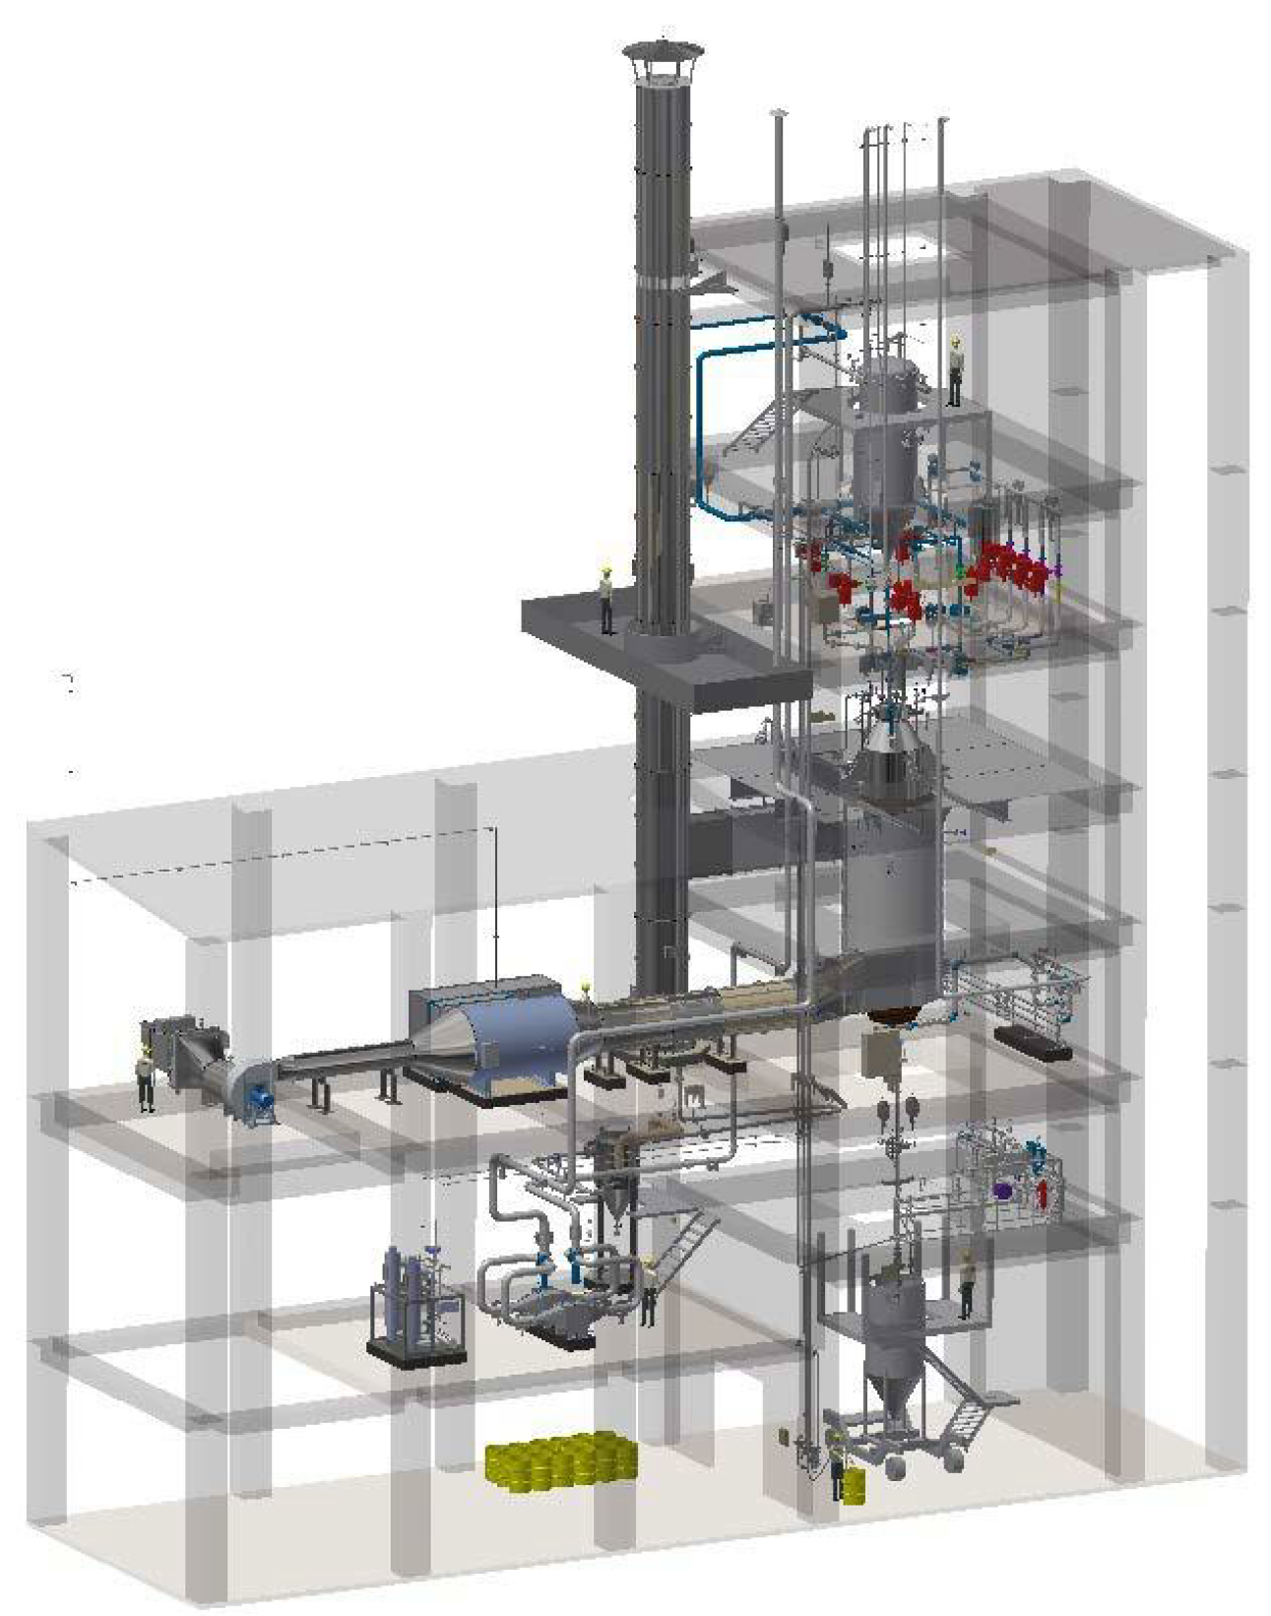

***Figure 1.*** *General view of the chrome catalyst activation unit*

The activated catalyst is discharged into the containers for the activated chromium catalyst **40-V-2003A-F** (for HDPE production) and into the containers **30-V-3802A-G** (for LLDPE /HDPE production), in which the activated catalyst is kept under the nitrogen blanket before use at the stage of the catalyst preparation for polymerization. The volume of a transport container is **4 m3**.

Flexible hose for the treated MP nitrogen supply is connected to the valves of each container; the container is pre-purged before filling and the filled container is pressurized with nitrogen to the pressure of **0.3 MPa**. Generation of the nitrogen blanket guarantees the preservation of the activated catalyst quality. Nitrogen pressure monitoring is carried out by pressure gauges **4020-PI-028A-F**, with which the containers are equipped. The containers are also equipped with rupture disks **4020-PSE-021A-F** for protection against overpressure.

The containers are equipped with a sampling fitting located in the conical part of the container; a common panel with a sampling device **4020-SC-001N** is provided for sampling and subsequent analytical control in the laboratory conditions.

The total quantity of catalyst in one transport container shall not exceed **700 kg**. A container is weighed on the electronic crane scales **4020-WI-020A** provided with the maximum weight alarm when the container is getting filled with activated chromium catalyst. Then, mounted on the frame of a wheeled transport facility, the filled container is transported to the polymerization section. Outside the activation building, there is provided a sheltered area for the placement of transport containers with activated chromium catalyst.

Activation conditions (cycle time, maximum temperature, temperature stabilization time, etc.) depend on the activated catalyst. The requirements to the catalyst activation conditions are made according to the formulations (activation profiles) provided by the Licensor (INEOS). At that, the maximum activation temperature shall not exceed 900 °C.

The main stages of typical activation cycle are given below:

* Selection of the activation parameters depending on the catalyst to be activated;
* Loading of the original (crude) catalyst from the loading unit into the catalyst activator loading vessel **40-F-2001**;
* Transportation of the crude catalyst from the catalyst activator loading vessel **40-F-2001** into the internal vessel of the catalyst activator **40-R-2001**;
* Start of the catalyst activation;
* The first heating stage;
* Temperature stabilization (for drying);
* The second heating stage;
* Temperature stabilization;
* Transition from nitrogen to air;
* The third heating stage;
* Temperature stabilization (for activation);
* Cooling down;
* Transition from air to nitrogen;
* Final stage of cooling down;
* Catalyst unloading.

The duration of the complete cycle makes up from 16 to 40 hours, depending on the duration of the activation stage (activation profile).

The maximum heating rate is 2°C/min. The maximum cooling rate is 1.5°C/min at temperature above 300°C (mechanical limitation) and 4°C/min at temperature below 300°C.

The catalyst activator blower **40-BL-2001** operates during the cooling phase at the temperature below 260°C. It can also function during the heating process as an additional regulator of the released heat quantity.

The rate of gas supply from the internal vessel of the catalyst activator **40-R-2001** is under control: it shall make up 3-4 cm/sec in the upper part of the bed at the catalyst loading stage, 8 cm/sec during the nitrogen fluidization and 12 cm/sec during the air fluidization.

*Crude catalyst loading*

The crude catalyst is transported from the loading station to the internal vessel of the catalyst activator **40-F-2001** by pneumatic conveyor system. The draft force (under pressure) is generated by the loading ejector **40-EJ-2001**.

Then the catalyst flows by gravity into the internal vessel of the catalyst activator **40-R-2001**. To facilitate the catalyst unloading small overpressure is generated in the catalyst activator loading vessel **40-F-2001**.

During loading into the internal vessel of the catalyst activator **40-R-2001**, the catalyst is subjected to fluidization under the nitrogen or drained air atmosphere at the low feeding rate (recommended rate is 3-4 cm/sec). The supply of crude catalyst into the internal vessel of the catalyst activator **40-R-2001** is controlled by two two-position (ON/OFF) valves located one after another.

The transition to the activation stage is performed upon the loading completion.

*Activation stage*

The fluidization rate is increased to the operating rate of the stage (up to the rate value recommended by the Licensor).

The temperature of the catalyst rises to the values required for activation at the required rate. Upon reaching the activation temperature, it is stabilized throughout the entire stage (all parameters of the activation stage and temperature profiles are defined by the Licensor).

Fluidization gas is heated up with use of the electric fluidization air heater **40-E-2003** according to the temperature profile.

The walls of the internal vessel of the catalyst activator 40-R-2001 are also heated up by hot gases from the activator burner **40-MI-2004**, which pass through the jacket of the activator heater **40-H-2002**.

Temperature profile for the catalyst is defined by the Licensor.

Gases discharged from the vessel pass through the internal filter of the catalyst activator **40-F-2002**. This filter is cleaned automatically by the back flow of hot nitrogen.

The exhaust gases are cooled down with use of the fluidization air cooler **40-E-2001** (finned air radiator). They are pumped into the knock-out pot of the catalyst activator 40-V-2002 for dust separation and condensate recovery, and then they are fed to the external filters of the catalyst activator and released into the atmosphere.

At the end of the activation stage, the catalyst is cooled down by cooling the walls of the internal vessel of the catalyst activator **40-R-2001**. As a result, ambient air is supplied to the jacket of the catalyst activator heater **40-H-2002** with use of the activator blower **40-BL-2001**. Hot gases from the heater jacket are released into the atmosphere.

**3.2.4. Catalyst activator**

(Description of the Vendor’s diagram *ZSN.0404-4010-РО2204-120-0002*, sheet 4)

Package catalyst activator unit **40-PK-2002** includes the following systems:

1. Catalyst activator system

2. Catalyst loading system

3. Fluidization gas supply system

4. Fluidization gas exhaust system

5. Heater jacket system

6. Instruments and electrical equipment

*1. Catalyst activator system*

The catalyst activator system consists of three main parts: the internal vessel of the catalyst activator, the internal filter of the catalyst activator and the heater jacket of the catalyst activator:

***a) The internal vessel of the catalyst activator 40-R-2001 (to be installed indoors):***

The catalyst activator shall be installed in a vertical position and enclosed into the single cylindrical casing (diameter: 1,550 mm, height: 10,700 mm, made of alloy 601). A fluidization plate is located in the bottom part of the activator. Nitrogen or air is supplied under this plate through a diffuser welded to the activator casing. A nozzle is provided on the diffuser to remove excess product entering the diffuser.

In order to minimize temperature deformation, the catalyst activator has a support in the upper part. At the top of the catalyst activator there is a flange through which a filter is connected to the activator.

The reactor is equipped with several nozzles. The latter make it possible to orient the thermocouples and measure the pressure in the catalyst bed at different heights.

The fluidization plate is a drilled plate made of the casting alloy (alloy 601). The fluidization plate is attached to the reactor by a skirt, thus minimizing the impact of thermal expansion. For the same reason, sliding connecting jumpers are provided between the plate and the plate support. In addition to that, the catalyst activator is supplied with an electric heater **40-E-2003**, which increases the temperature of the fluidization gas to 625 °C.

The surface of the plate is slightly (by 5°) beveled to the center, thus simplifying the product unloading from the catalyst activator. Unloading is carried out through the nozzle welded to the plate top, similar to the diffuser chamber.

The discharge valve (diameter: 109 mm) is a conical bushing through which the access to the center of the plate is blocked. At that, tightness is achieved by using a metal-to-metal saddle made of stellite. The valve is controlled by a vertical rod of a pneumatic cylinder. To ensure the safety and correct orientation of the rod, it is placed into the special pipe. The discharged product enters the annular space between this pipe and the valve body. The space around the rod is protected from atmospheric air by the bellows.

A sight glass is provided for control over the product unloading.

|  |  |
| --- | --- |
|  |  |
| ***Figure 8.*** *Internal filter* |
|  |
| ***Figure 7.*** *Catalyst activator with heater jacket (COMESSA) – General view* | ***Figure 9.*** *Buffer vessel* |

***b) Internal filter of the catalyst activator 40-F-2002 (to be installed indoors):***

The activator is equipped with a flanged filter located at the top. The filter consists of 52 porous metal-ceramic filter elements fixed with bolts to the flat support. Filter cleaning is carried out by back nitrogen flow. The nitrogen flow is heated up in the electric heater **40-E-2005**, which is installed downstream the buffer vessel containing the preset volume of nitrogen (3.05 m3).

***c) Heater jacket of the catalyst activator 40-H-2002 (to be installed indoors):***

As the fluidization rate and fluidization energy are small, the major heat volume is supplied through the activator casing.

The heating system consists of the heater jacket, which is installed tangentially to the bottom part of the vessel with hot vapors coming out of the chamber with direct combustion. An exhaust hood is provided in the top part of the heater jacket. The capacity of the burner ready for operation is 1400 kW. The heater jacket can be dismantled for maintenance and repair.

|  |  |
| --- | --- |
|  |  |
| ***Figure 10.*** *Heater jacket of the catalyst activator– General view* | ***Figure 11.*** *Heater jacket in the closed (marked black) and open condition (marked blue)* |

*The outer casing* consists of two parts connected by bolts. They are made of painted carbon steel and supported by the guide. The thickness of each part makes up 8 mm. Each part is equipped with supporting hooks for ceramic fibre.

A nozzle is arranged both in the bottom and in the top part of the casing for the intake and exhaust of hot gases, respectively.

*Internal insulation*

The bottom part of the casing, in the section upstream the inlet of hot gases, is additionally protected by heat-resistant concrete. Other parts of the casing contacting with hot gases are made of ceramic fiber under vacuum. This part of the casing is characterized by high hardness and can withstand air pressure with speed of up to 20 m/s. The remaining insulation elements are made of ordinary ceramic fiber and are fixed by studs. The total thickness of the insulation coating is 300 mm.

***d) Smoke stack of catalytic gas 40-ST-2001 (to be installed outdoors)***

Gases enter the smoke stack from the heater jacket. The latter is a semi-fixed structure for installation on a building and consists of the following parts and items:

* vertically positioned stainless steel pipe with fireproof lining;
* inlet nozzle with a flange for connection to the pipe;
* base plate and the necessary pads for it;
* exhaust gas sampling points on the support and on the pipe;
* a set of anchor bolts with nuts and gasket washers for them;
* grounding points at the base of the pipe;
* inspection holes.

Total height makes up about 26,630 m (without bird screens).

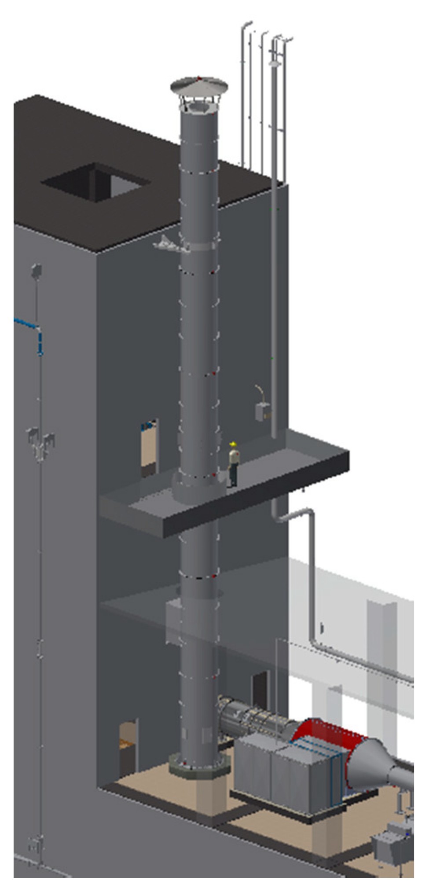

***Figure 12.*** *Smoke stack – General view*

The chromium catalyst is loaded into the internal vessel of the catalyst activator 40-R-2001 on the base under which the fluidization gas (nitrogen or air) is supplied from the fluidization gas distribution station.

The catalyst activation process is carried out in the fluidized nitrogen/ air bed in the internal vessel of the catalyst activator **40-R-2001** under the high-temperature conditions, which are provided by the activator heater **40-H-2002**. This heater is a jacket attached to the internal vessel of the catalyst activator, it is a fire-type heater with supply of combustion gases from the burner **40-MI-2002**. The exhaust combustion gases are released into the atmosphere through the exhaust pipe.

With the help of the monitoring and control system, the catalyst is automatically heated up and activated in the stage-wise mode.

Brief specifications of process equipment

|  |  |  |  |  |  |  |
| --- | --- | --- | --- | --- | --- | --- |
| Ser.  № | Tag number in the diagram | Name of equipment or hardware | Quantity, pcs. | Material | Protection method | Technical data |
| 1 | 2 | 3 | 4 | 5 | 6 | 7 |
| 1 | **40-V-2001A/B**  **(**in the scope of  **40-PK-2001)** | Air drying vessels | 2 | Low temperature carbon steel |  | Vertical vessel:  V = 0.132 m3  Н = 2,108 mm  D = 324 mm  Тdesign = minus 52 / 200°С  Рdesign= 1.3 МPа |
| 2 | **40-E-2004**  **(**in the scope of  **40-PK-2001)** | Electric heater of dry air | 1 | Low temperature carbon steel |  | Electric heater  Т design = minus 52 - 400°С  Power = 6.0 kW  Рdesign = 1.3 МPа  Рoper. = 0.8 МPа |
| 3 | **40-F-2005**  **(**in the scope of **40-PK-2001)** | Air drying filter | 1 | Low temperature carbon steel |  | Cartridge filter.  V = 0.015 м3  Н = 829 mm  D = 168.3 mm  Рdesign.=1.3 МPа  Pressure drop, maximum – 0.08 MPa  Тdesign = minus 52 - 80°С |
| 4 | **40-E-2003** | Electric heater of fluidization gas | 1 | Stainless steel |  | Electric heater  Medium : nitrogen, process air  Power : 70 kW  Рdesign.=1.15 МPа  Тdesign = minus 52 / 650°С  Рoper =0.08 MPa  Тoper. = minus 39 / 625°С  Version - Ex d IIC T3 |
| 5 | **40-R-2001** | Internal vessel of catalyst activator | 1 | Nickel-chromium alloy |  | Vertical vessel:  Medium: chromium catalyst, nitrogen, process air  Voper. = 12.7 m3  H cyl = 10,624 mm  W = 1,550 mm  Тdesign = minus 39 / 920°С  Рdesign = 0.035 МPа  Рoper =0.015 МPа  Тoper.= minus 39 / 845°С |
| 6 | **40-ST-2001** | Smoke stack | 1 | Stainless steel |  | H = 27 143 m  D = 1 412 mm (outer)  D = 800 mm (inner)  Тdesign = minus 52 / 950°С  Тoper.= minus 39 / 900°С  Рoper =0.1058 МPа |
| 7 | **40-F-2002** | Internal filter of catalyst activator (40-R-2001) | 1 | Housing: Nickel-chromium alloy  Filter elements: Hastelloy X |  | Vertical vessel  Medium: nitrogen, catalyst, air  Н = 1,396 mm  D = 984.2 mm  D = 54 mm  Н = 1,000 mm  Рdesign.= 0.035 МPа  Тdesign = minus 39 / 920°С  Pressure drop, МPа – 0.0014 (in clean condition)/ 0.007 (in plugged condition)  Тoper.= minus 39 / 920°С |
| 8 | **40-Е-2005** | Electric heater | 1 | Stainless steel |  | Electric heater  Medium: nitrogen  Power : 23 kW  L= 3,444 mm  H= 796 mm  Рdesign.=1.3 МPа  Тdesign = minus 52 / 500°С  Рoper =0.025 МPа  Тoper.= minus 39 / 300°С  Version : Ex d IIC T3 |
| 9 | **40-V-2004** | Intermediate vessel | 1 | Stainless steel |  | Vertical vessel  Medium: nitrogen  V = 0.69 m3  Н = 2,000 mm  D = 800 mm  Рdesign.= 0.035 МPа  Тdesign = minus 52 / 80°С  Рoper =0.025 МPа  Тoper.= minus 39 / 50°С |
| 10 | **40-E-2002** | Electric heater of combustion air | 1 | Stainless steel |  | Electric heater  Power, design : 375 kW  Power consumption, maximum: 240 kW  W = 1,200 mm  D = 520 mm  H = 1,274 mm  Рoper.=0.005 МPа  Тdesign = minus 52 / 40°С  Тoper.= minus 39 / 5°С |
| 11 | **40-F-2004** | Inlet filter of catalyst activator blower | 1 | Stainless steel |  | Cartridge filter.  L = 1,529 mm  Н = 1,440 mm  Pressure drop, operating:  0,00025 МPа  Pressure drop, maximum:  0,0004 MPa  Тdesign = minus 52 / 40°С  Рoper - - atm.  Тoper.= 5 / 40°С  Filtering element  L = 592 mm  D = 592 mm  Volume of filtering element = 0.03 m3  Filter bed : synthetic fiber |
| 12 | **40-BL-2001** | Air blower | 1 | Carbon steel |  | Type: centrifugal  Flow rate oper. = 4 700 – 13 600 kg/h  Flow rate design = 21,931 kg/h Pressure head – 7335 Pa  Тdesign = minus 52 / 40°С  Тoper.= 5 - 40°С  Motor capacity = 45 kW  Version : IP 55 |
| 13 | **40-MI-2004** | Burner of catalyst activator | 1 | Stainless steel |  | Type : built in the air duct “HC” (1 ft.) Airflo®  Maxon Honeywell C7061F1003  Dimensions: 460 х 500 mm  Capacity = 1,400 kW  Natural gas flow rate design = 114 kg/h  Рdesign = 1.35 МPа  Тdesign = minus 52 / 80°С  Natural gas flow rate oper. = 26 – 88 kg/h  Рoper = 0.63 / 1.12 МPа |
| 14 | **40-F-2001** | Catalyst activator loading vessel | 1 | Stainless steel |  | Vertical vessel  V = 7.75 m3  Н = 6,230 mm  D = 1,510 mm  Рdesign.= minus 0.1/0.035 МPа  Тdesign = minus 52 / 70°С  Рoper = minus 0.09 / 0.01 МPа  Тoper.= minus 39 / 50°С |
| 15 | **40-EJ-2001** | Ejector | 1 | Stainless steel |  | Flow rate of impelling medium (process air), operating: 243 kg/h  Flow rate of process medium (process air), operating: 595 kg/h  Flow rate of medium at the outlet (process air), operating: 838 kg/h  Рdesign.= 1.3 МPа (impelling medium)  Рdesign.= 0.05 / ПВ (supply air?) МPа (process medium)  Тdesign = minus 52/120°С  Тoper.= 39 / 50°С  Рoper = 0.37 / 0.9 МPа (impelling medium)  Рoper = minus 0.005 МPа (process medium) |
| 16 | **40-V-2005** | Vessel of back-purge system | 1 | Stainless steel |  | Vertical vessel  Medium: air  V = 0.026 m3  L = 380 mm  D = 219 mm  Рdesign.= 1.0 МPа  Тdesign = minus 52 / 80°С  Тoper.= 39 / 50°С |
| 17 | **40-Е-2001** | Fluidization air cooler | 1  (3 elements) | Stainless steel |  | Finned heat-exchanger  Medium: air, nitrogen, hydrocarbons  Heat duty: 64 kW  Heat-exchange surface (total) F=52 m2  Рdesign. = 0.035 МPа  Тdesign = minus 52 / 816°С  Рoper = 0.011 МPа  Тoper.inlet = 5 / 654°С  Тoper.outlet = minus 52 / 200°С |
| 18 | **40-V-2002** | Knock-out pot of catalyst activator | 1 | Stainless steel |  | Vertical vessel  Medium: air, nitrogen, hydrocar-bons, catalyst particles  V = 1.8 m3  Н = 3 965 mm  D = 1 200 mm  Рdesign.= 0.035 МPа  Тdesign = minus 52 / 200°С  Тoper.= minus 39 / 200°С  Рoper = 0.01 МPа |
| 19 | **40-V-2003A-F** | Containers for activated chromium catalyst | 6 | Low temperature carbon steel |  | Vertical vessel  Medium: activated chromium catalyst  V = 3.996 m3  Н = 4,310 mm  D = 1,600 mm  Рdesign.= 1.0 МPа  Тdesign = 150°С  Рoper = 0.3 МPа  Тoper.= ambient |
| 20 | **40-F-2003A/В** | External filter of catalyst activator | 2 | Housing - Stainless steel,  Internals - Stainless steel |  | Cartridge filter  Medium: air, nitrogen, hydrocar-bons, catalyst particles  L = 2,311 mm  D = 691 mm  Pressure drop : up to 0.00002 MPa  Рdesign.= 0.035 МPа  Тdesign = minus 52 / 200°С  Тoper.= minus 39 / 200°С  Рoper = 0.01 МPа  Filtering element  L = 610 mm  D = 292 mm  Filtering bed – fibre glass |